Case study: Where is the best place to open a day tour company that searches for Bigfoot?

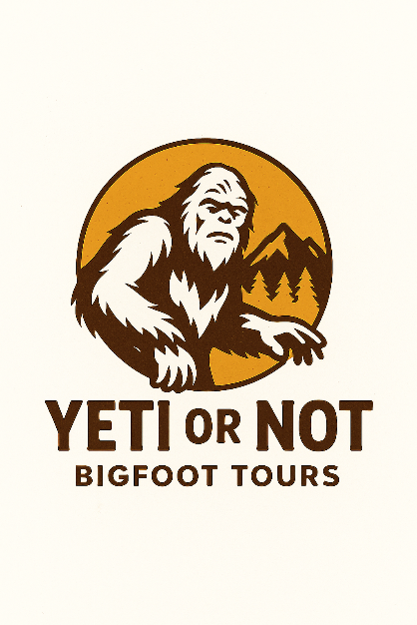

## Business Task

Locate the best state and season to open a touring company based on Bigfoot sightings

## Ask

* Which state has the most Bigfoot sightings?
* What season has the most Bigfoot sightings?

## Things to consider

* Is extreme weather a factor?

## Sources

Bfro_locations_cleaned.csv

Bfro_reports_cleaned.csv

Bigfoot_count_by_month.csv

Bigfoot_count_by_season.csv

Bigfoot_count_by_state.csv

Bigfoot_count_by_year.csv

Libraries import